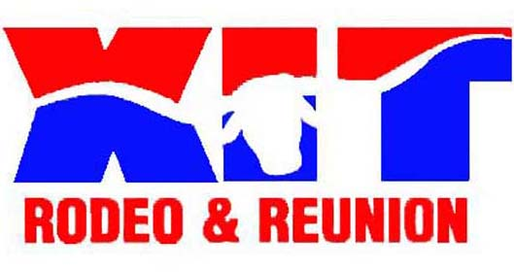

Hold Harmless Agreement
XIT Rodeo & Reunion
P.O. Box 966 , Dalhart, TX 79022

HOLD HARMLESS AGREEMENT

WHEREAS, the undersigned is providing a service to and/or utilizing the facilities of the XIT Rodeo and Reunion; and

WHEREAS, such service and/or use requires the undersigned to be in and around the premises and business operations of XIT Rodeo and Reunion; and

NOW, THEREFORE, in consideration of being permitted in and around the premises and business operations of XIT Rodeo and Reunion and for other good and valuable consideration, the undersigned hereby agrees to protect, indemnify and hold harmless XIT Rodeo and Reunion, its subsidiaries or affiliated companies, directors, officers, employees, agents and assigns, against and from any and all liability of any and every kind, nature or description for injury to or death of any person or persons whomsoever and for loss or damage to any property whatsoever, together with all costs and expenses incident thereto arising in any manner, directly or indirectly, out of or in connection with the performance of services rendered and/or use of, provided such indemnification shall not extend to injury, death, loss or damage caused by the gross negligence or willful misconduct of XIT Rodeo and Reunion or its Directors.

IN WITNESS WHEREOF, the undersigned has hereunto set their hand and seal this ______ day of ________________, 2018.

_______________________________
Print full name

_______________________________
Signature

_______________________________
Witness

